DEPLOYING PROJECT IN JENKINS

Go to Jenkins

Click on create new item

Select pipeline

In pipeline script put:

pipeline{

agent any

stages{

stage("git checkout"){

steps{

echo "starting with git checkout"

git url: "https://github.com/akshu20791/DevOpsClassCodes"

echo "git checkout done"

}

}

stage("compile the code"){

steps{

echo 'compiling is starting'

sh "mvn compile"

}

}

stage("testing the code"){

steps{

echo "testing to be started"

sh "mvn test"

}

}

stage("qa the code"){

steps{

echo "qa to be started"

sh "mvn checkstyle:checkstyle"

recordIssues sourceCodeRetention: 'LAST_BUILD', tools: [checkStyle()]

}

}

stage("packaging the code"){

steps{

echo "package the code"

sh "mvn package"

}

}

}

}

## USE YOUR FORKED REPO IN THE GITHUB URL

SAVE

Build the job

Go to terminal of the machine

wget <https://dlcdn.apache.org/tomcat/tomcat-8/v8.5.100/bin/apache-tomcat-8.5.100.zip>

apt install zip -y

unzip apache-tomcat-8.5.100.zip

mv apache-tomcat-8.5.100 /opt

ls

cd /opt

ls

(you will see the tomcat folder)

cd apache-tomcat-8.5.100

**## my tomcat works in 8080 port ….since this port is used by Jenkins I will have to change it**

cd config

vi server.xml

press i

scroll down to line 69 and replace8080 with 9090

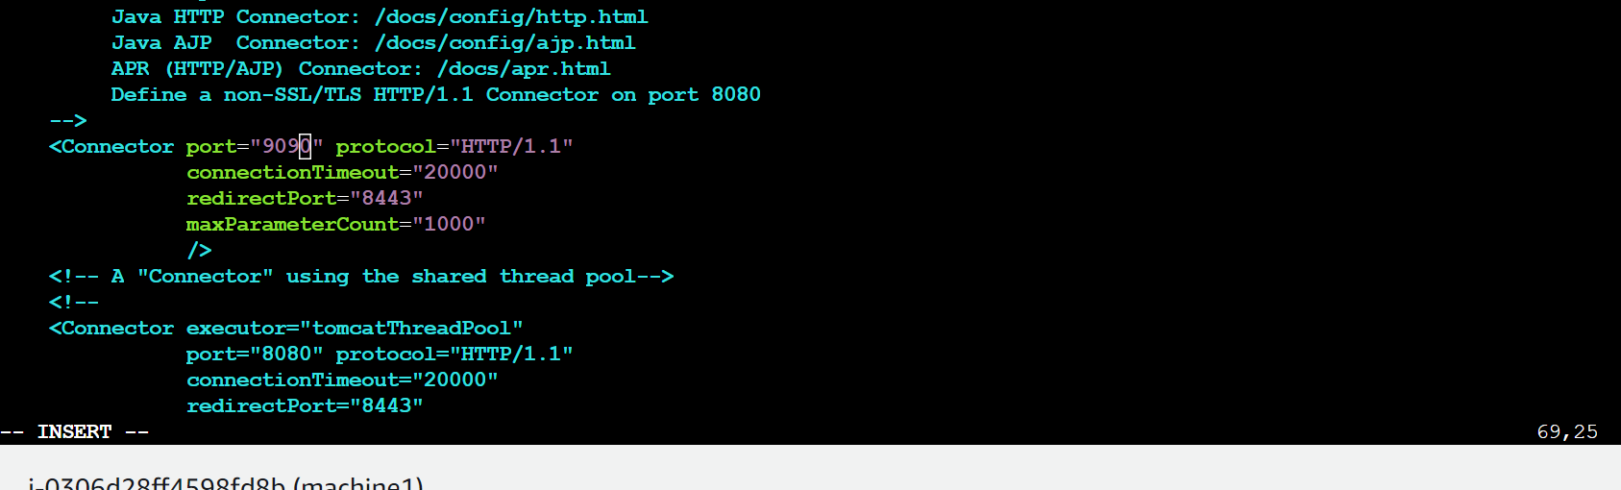



cd ..

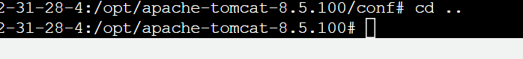

cd bin

chmod +x *.sh

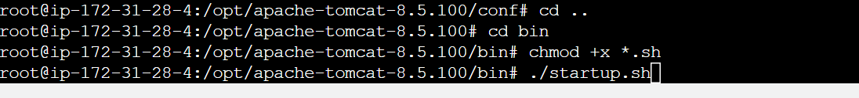./startup.sh

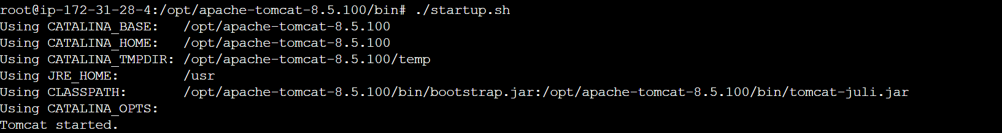

cd ..

Now open chrome /firefox

If you are working in some machine running locally use localhost:9090

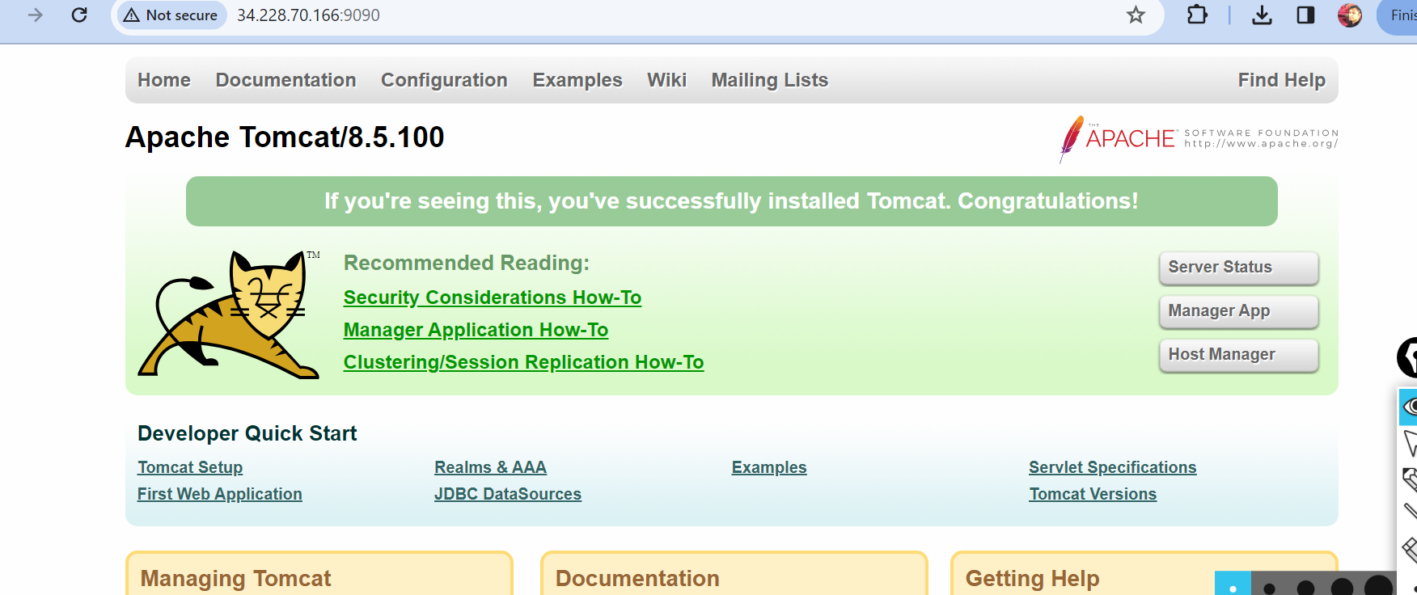



Click on manager app

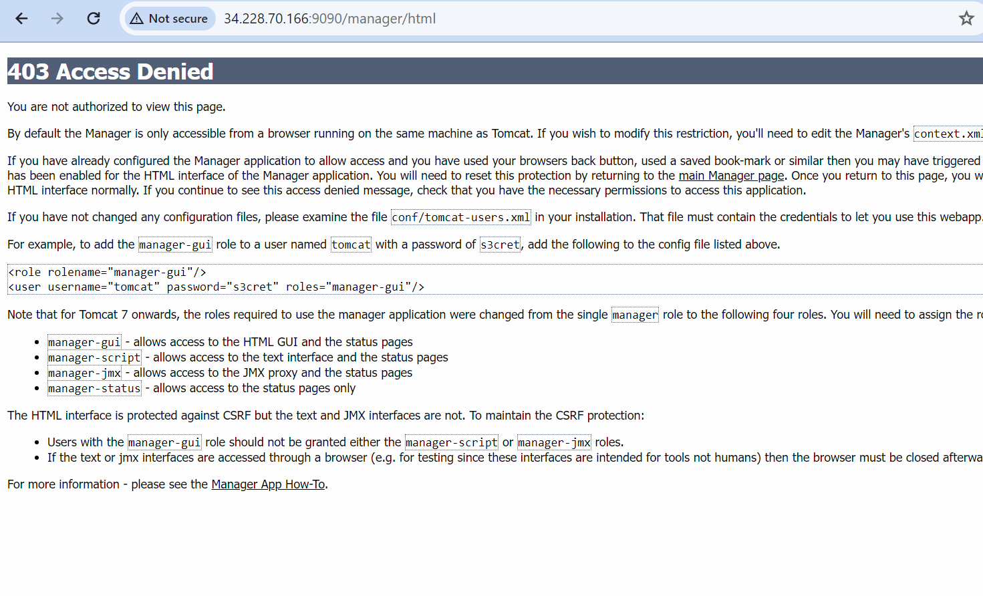

Lets go back to terminal

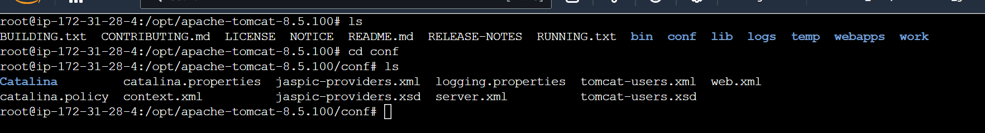

ls

cd conf

ls

vi tomcat-users.xml

Copy the error message in the above file

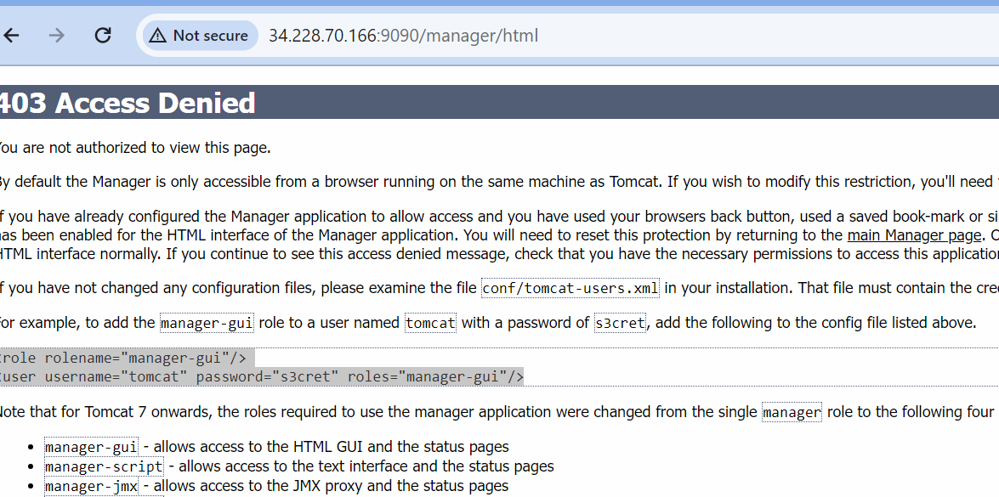

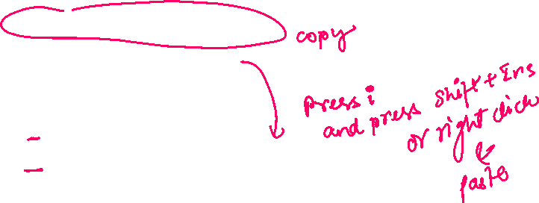

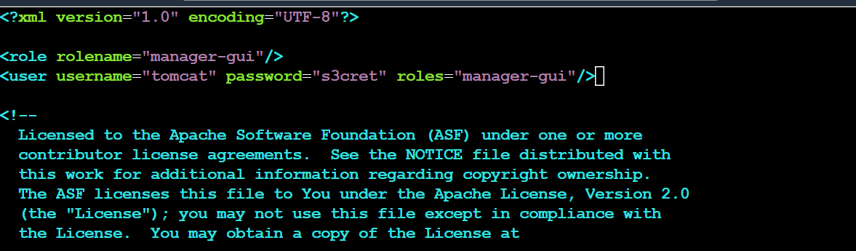



Press esc :wq to save and quit

cd ..

ls

cd webapps

ls

cd manager

ls

cd META-INF

ls

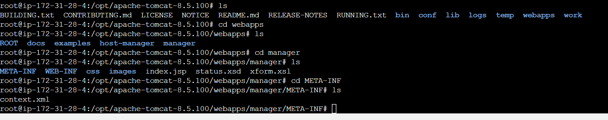

vi context.xml

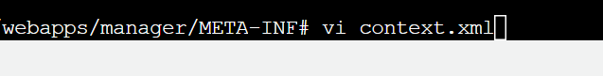

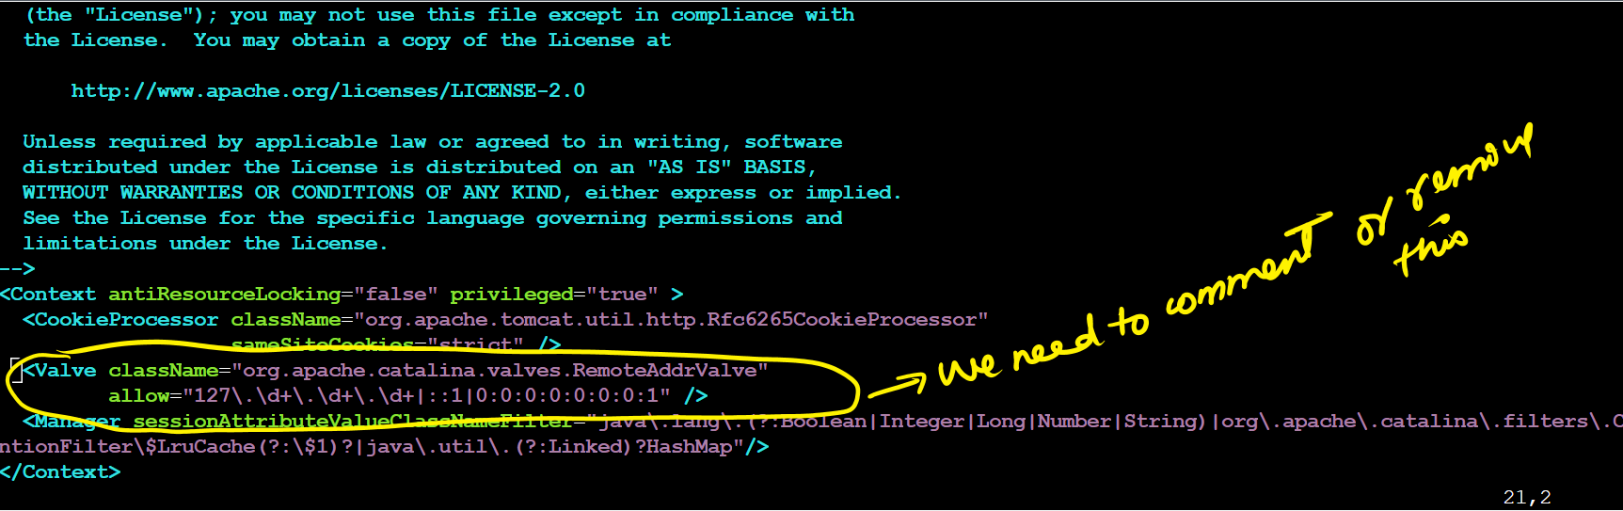

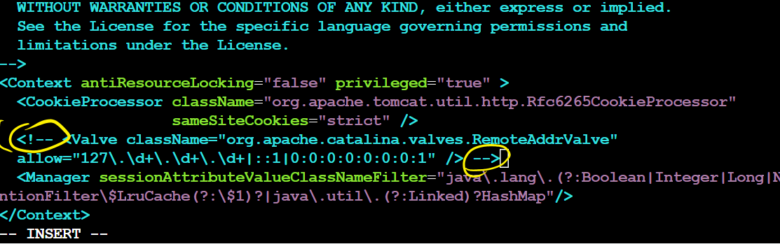

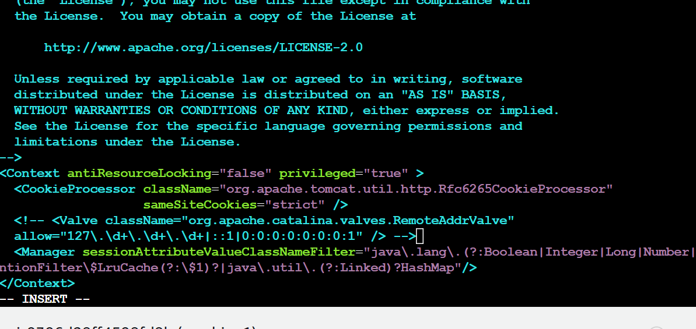

cd ..

cd ..

cd ..



#######

cd bin

./shutdown.sh

./startup.sh

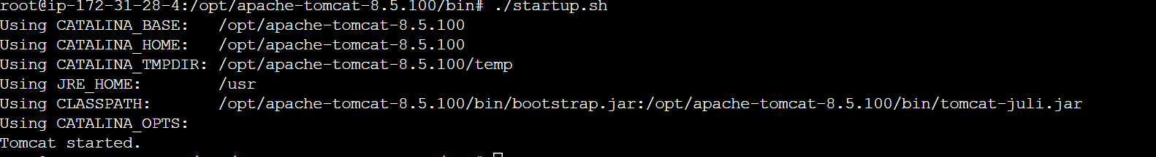

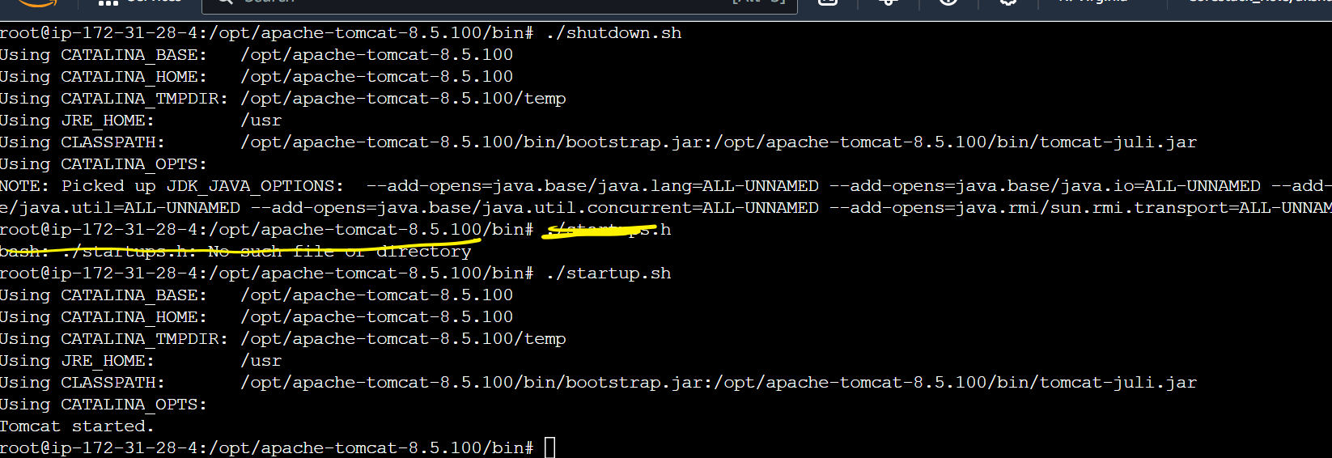

Go to tomcat and check if manager app is working

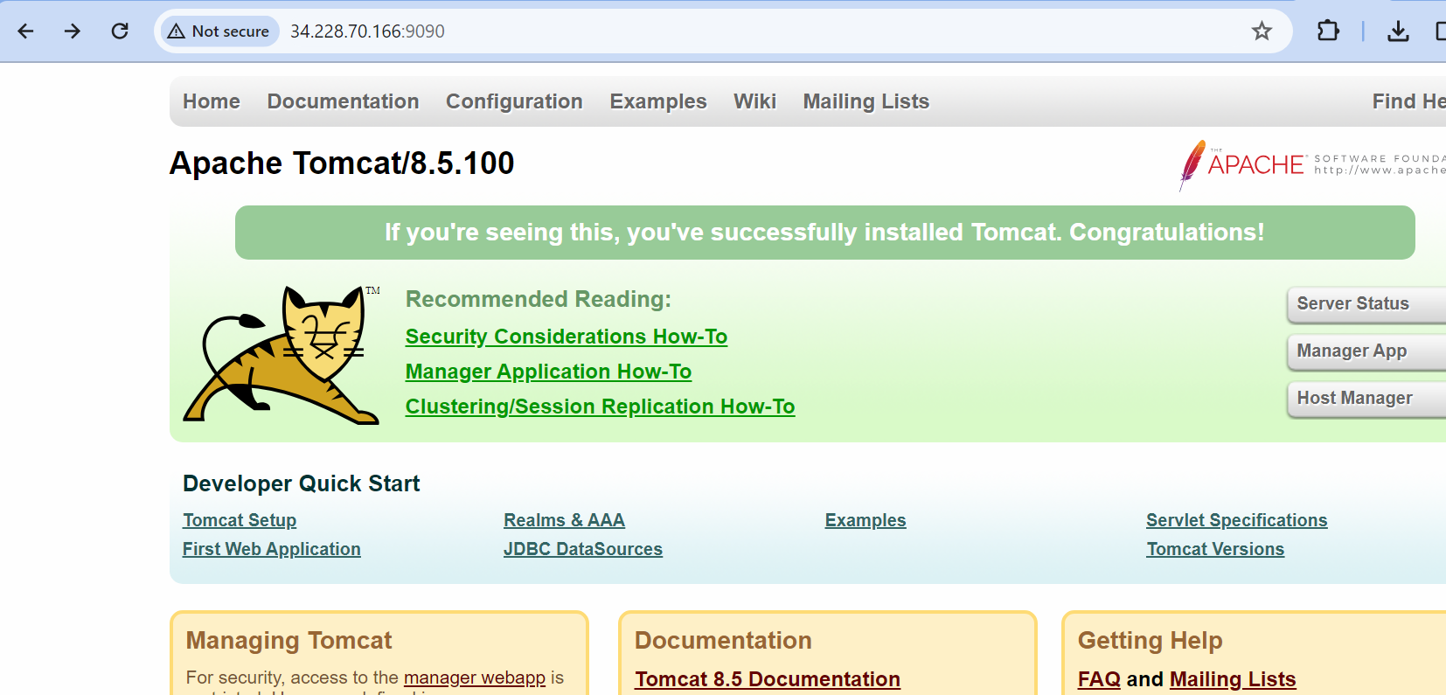



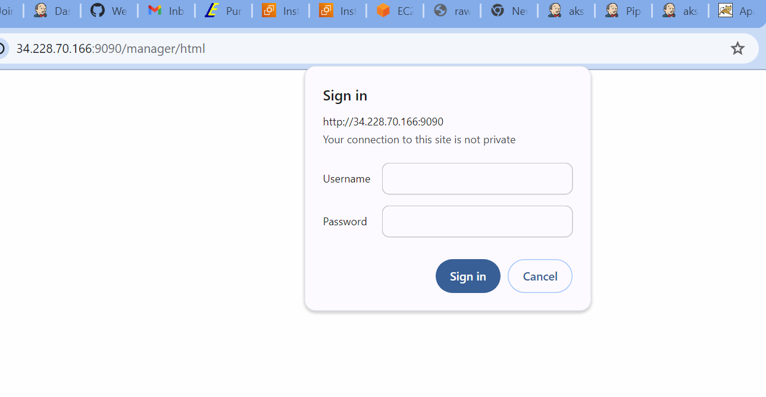

There is war file which is present in Jenkins workspace…we need to copy that war file in tomcat

We will add one more stage in the pipeline

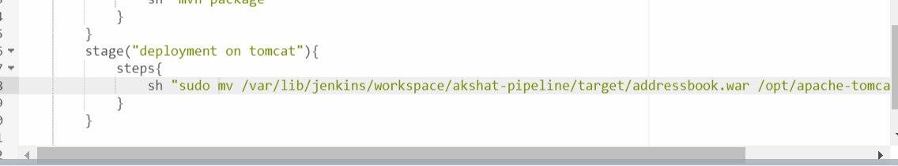

pipeline{

agent any

stages{

stage("git checkout"){

steps{

echo "starting with git checkout"

git url: "https://github.com/akshu20791/DevOpsClassCodes"

echo "git checkout done"

}

}

stage("compile the code"){

steps{

echo 'compiling is starting'

sh "mvn compile"

}

}

stage("testing the code"){

steps{

echo "testing to be started"

sh "mvn test"

}

}

stage("qa the code"){

steps{

echo "qa to be started"

sh "mvn checkstyle:checkstyle"

recordIssues sourceCodeRetention: 'LAST_BUILD', tools: [checkStyle()]

}

}

stage("packaging the code"){

steps{

echo "package the code"

sh "mvn package"

}

}

stage("deployment on tomcat"){

steps{

sh "sudo mv /var/lib/jenkins/workspace/akshat-pipeline/target/addressbook.war /opt/apache-tomcat-8.5.100/webapps/"

}

}

}

}

Save and build the project

You will see error in the deployment stage

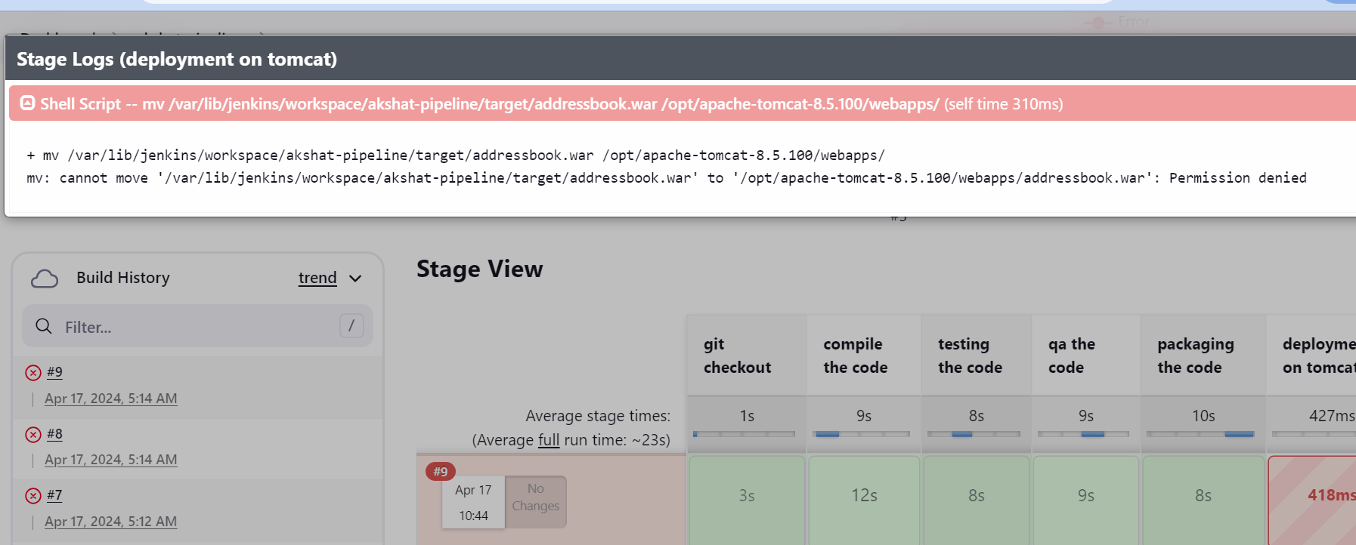

Here my Jenkins does not have enough permissions to move the war file from the workspace to the tomcat

Now need to give Jenkins the permission to act like a root user

Go to terminal

visudo





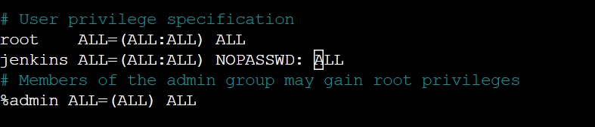jenkins All=(ALL:ALL) NOPASSWD: ALL



Press ctrl x then press y and then press enter to come out of nano editor

Lets restart the Jenkins

service jenkins restart



Go to Jenkins….and refresh

You have to again relogin to Jenkins

Now build the pipeline again

